INT 348 - BOT AUTOMATION
CA1 PROJECT REPORT

On
Copy Text from Image

School of Computer Science & Engineering
LOVELY PROFESSIONAL UNIVERSITY
November 2022


SUBMITED TO – Dr. Suma Kamalesh Gandhimathi

Name:-Ravi Pandey
Registration no:-11910459

- Name of the Project: Copy Text from Image

- Technical Requirements: textimage ,uipath,wordfile.

- Description/ Project Overview (Min 400 words):

In this project I have use one text image from which I have copy the text from image using uipath and then I show using message box .then save that text into document file using uipath.

- Screenshots of all Workflows:

Textimage

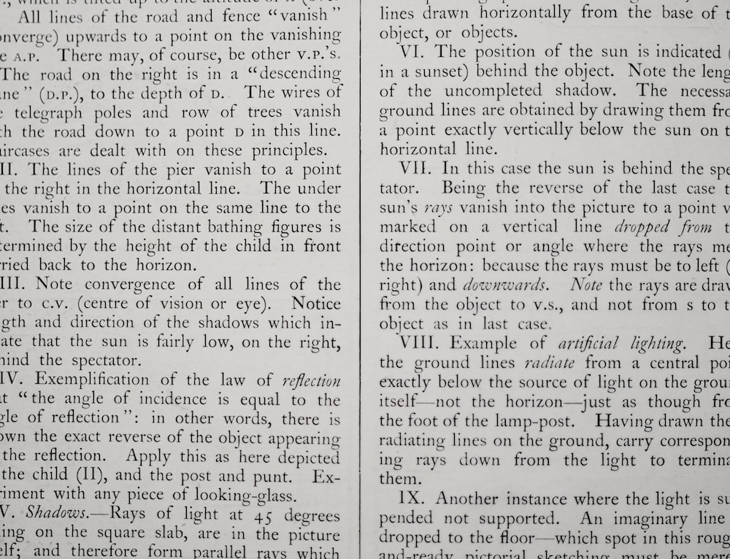

I have use get ocr text for extract text from image.

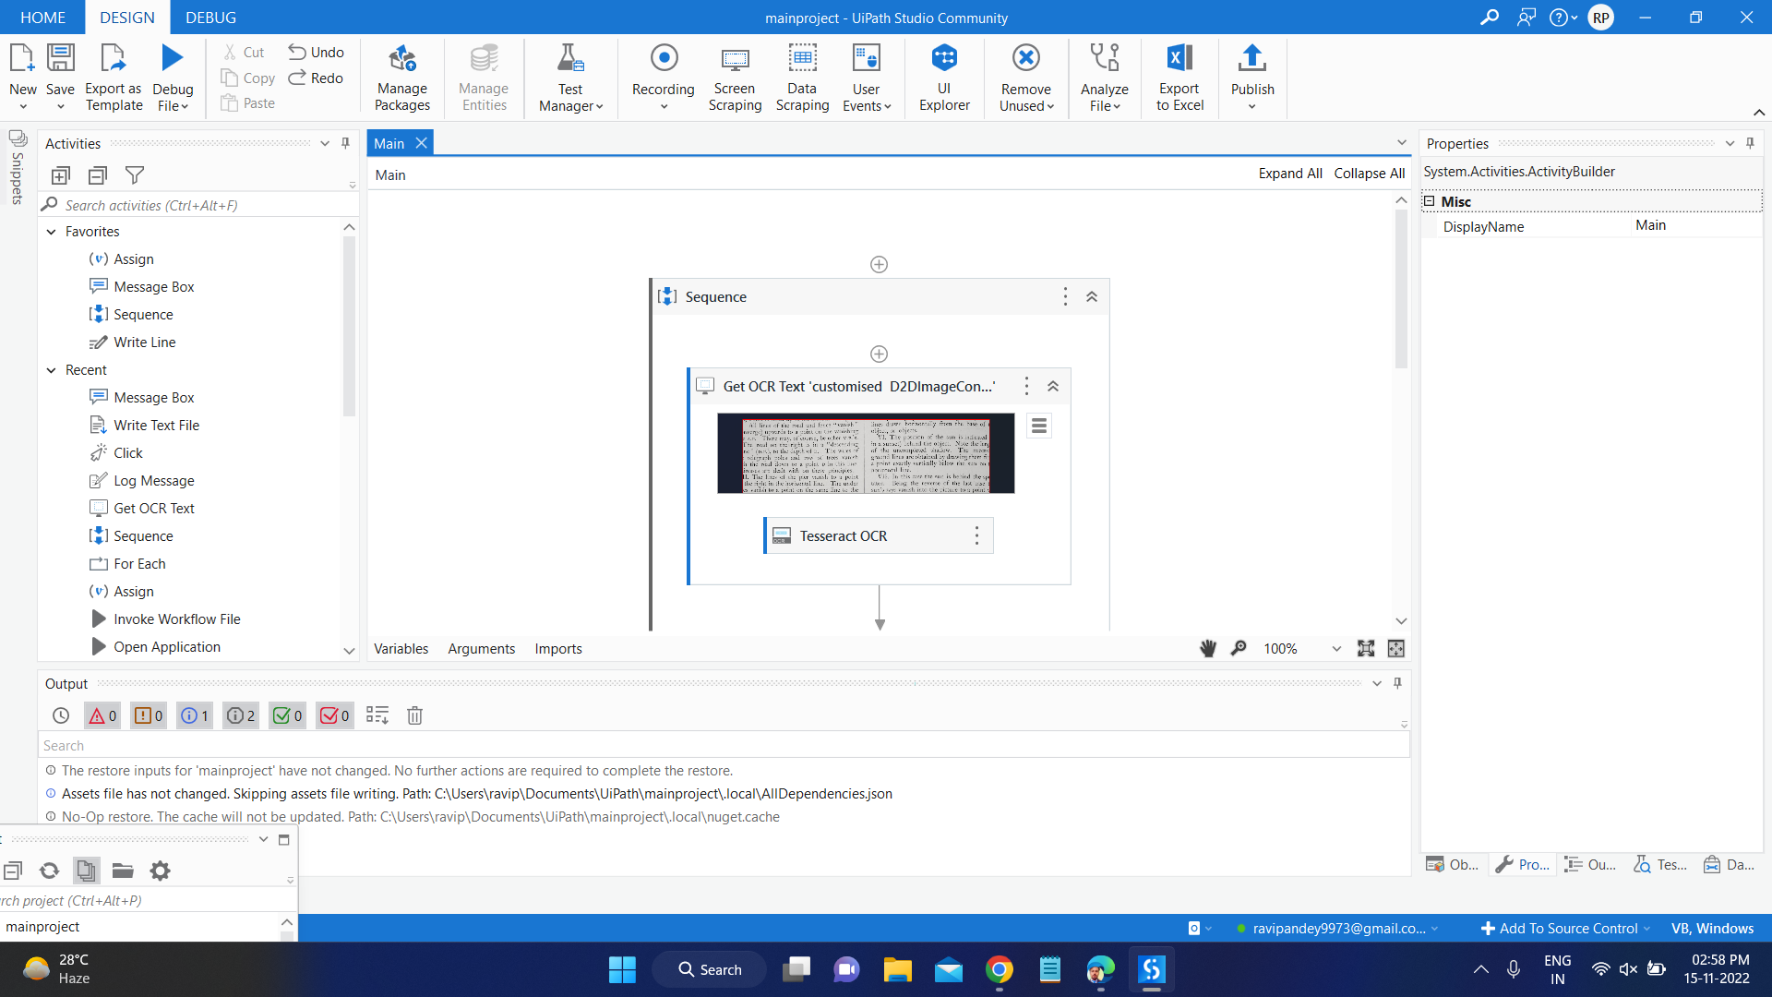

I have use log message for store the data which I extract from image.

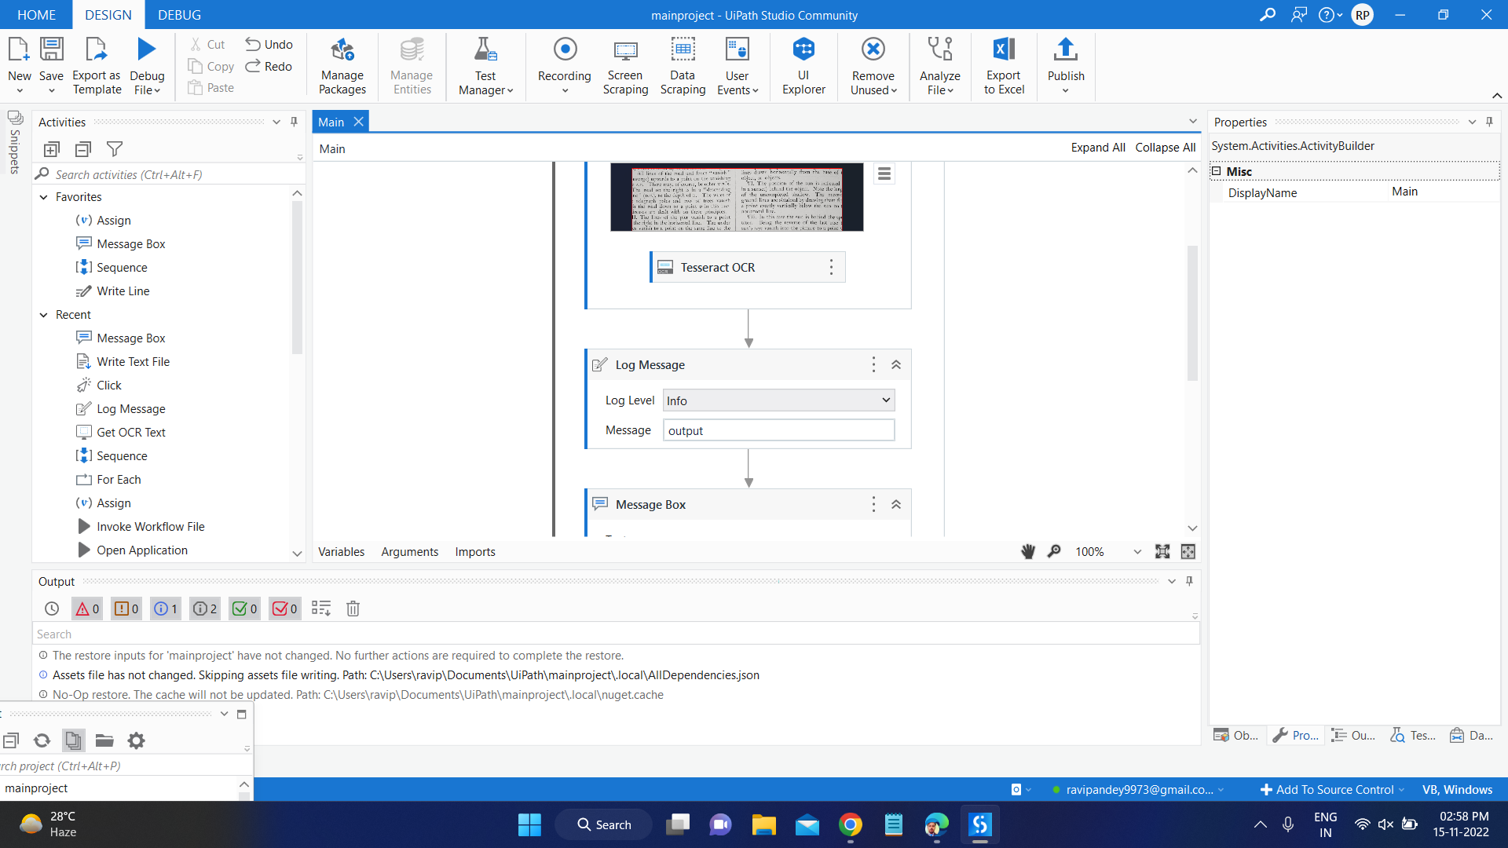

Then I use message box to print the output which extract from image.

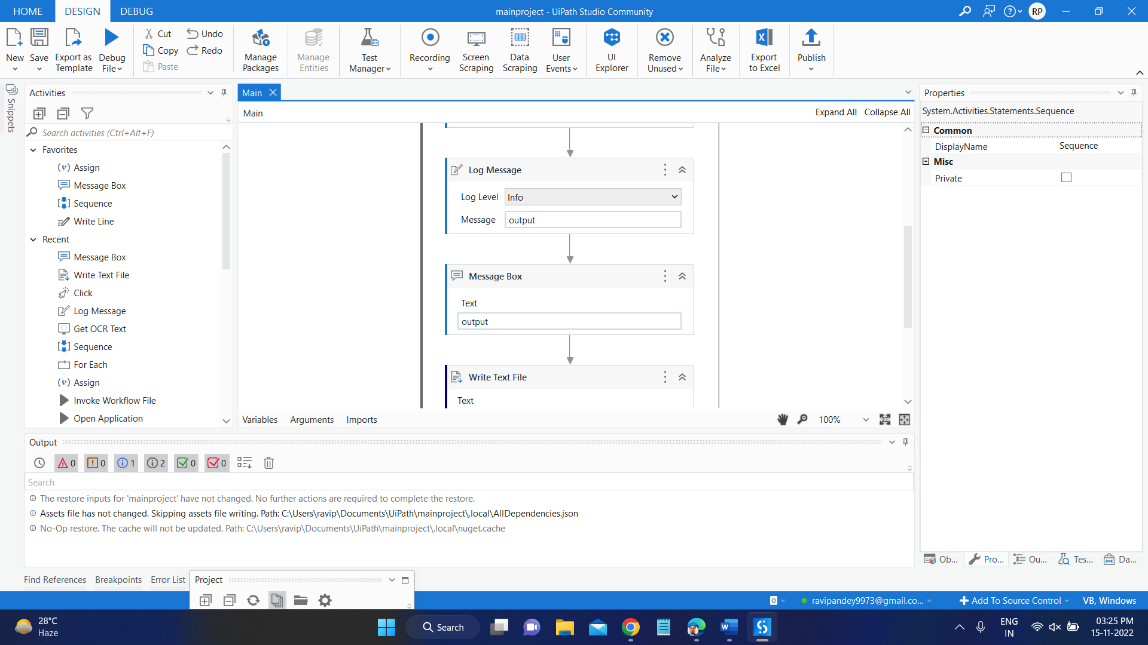

The I have use write text file for write exracting text from image into word file.

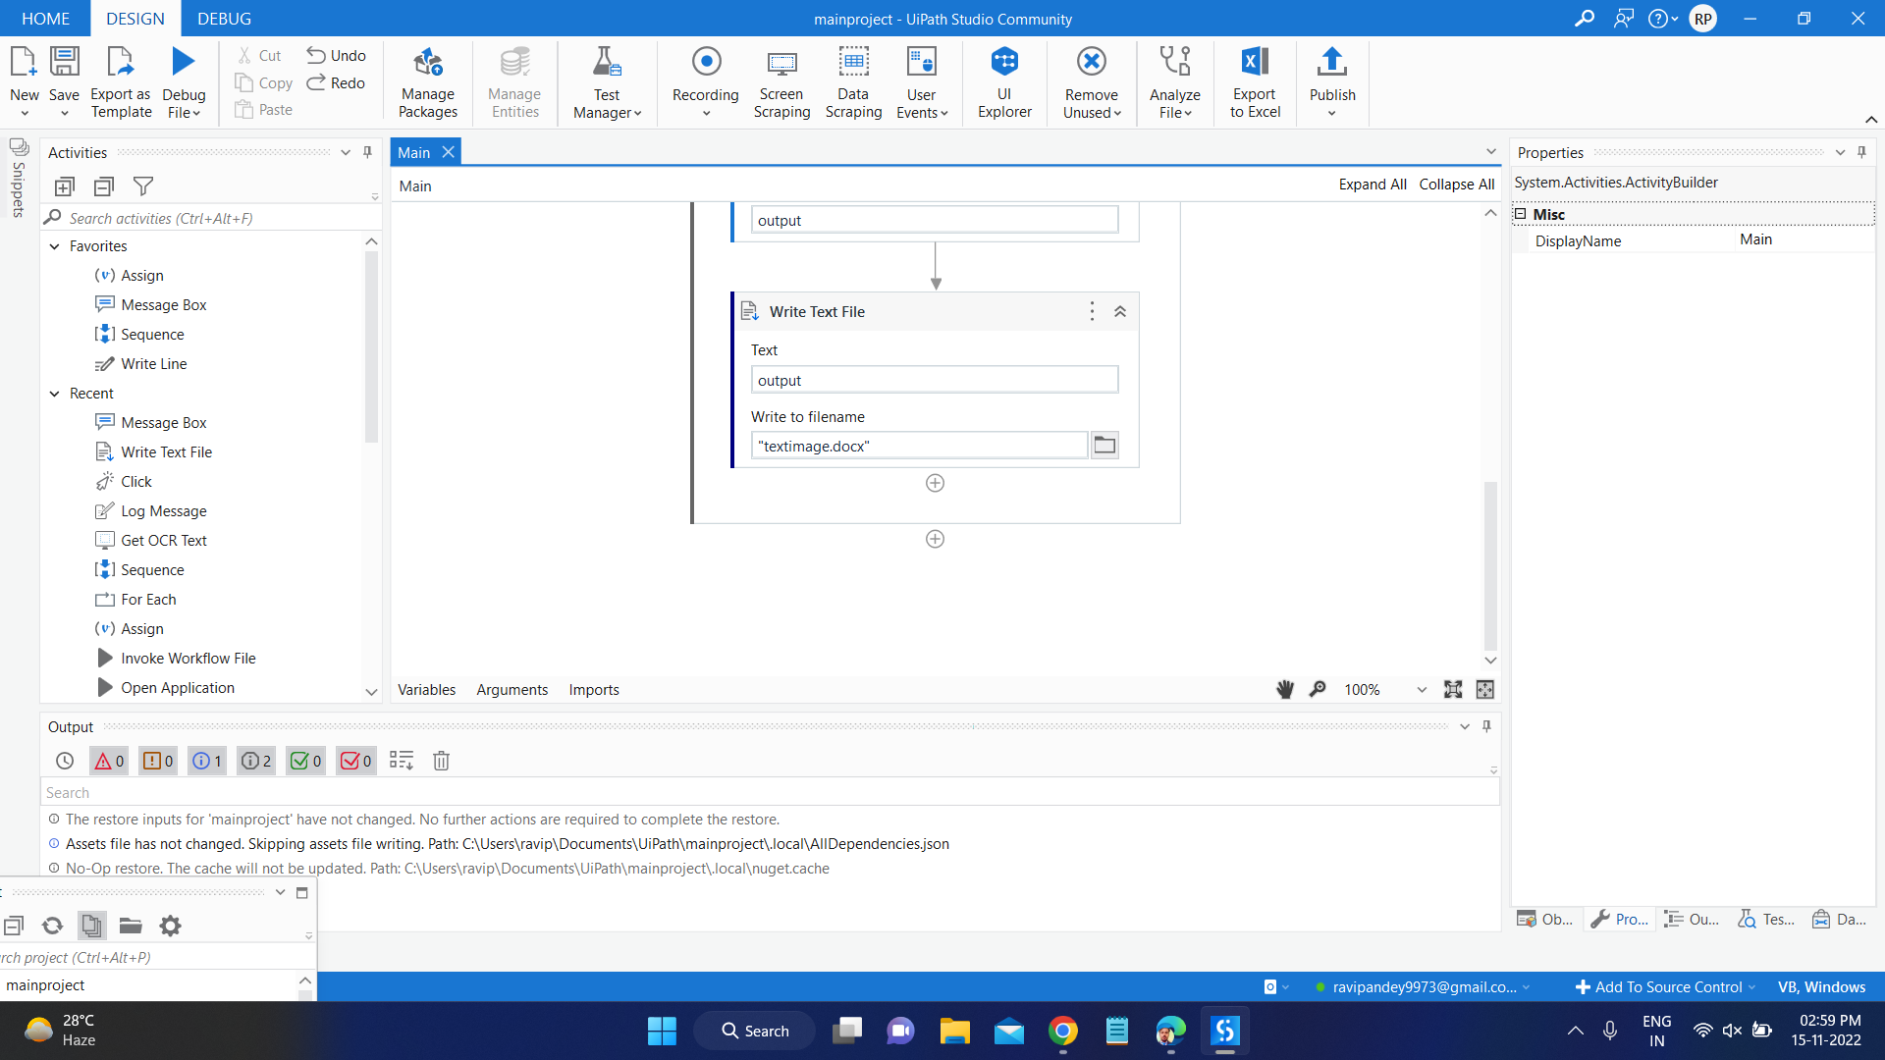

- Screenshots of Output Screens:

Message box contain extracting text from image.

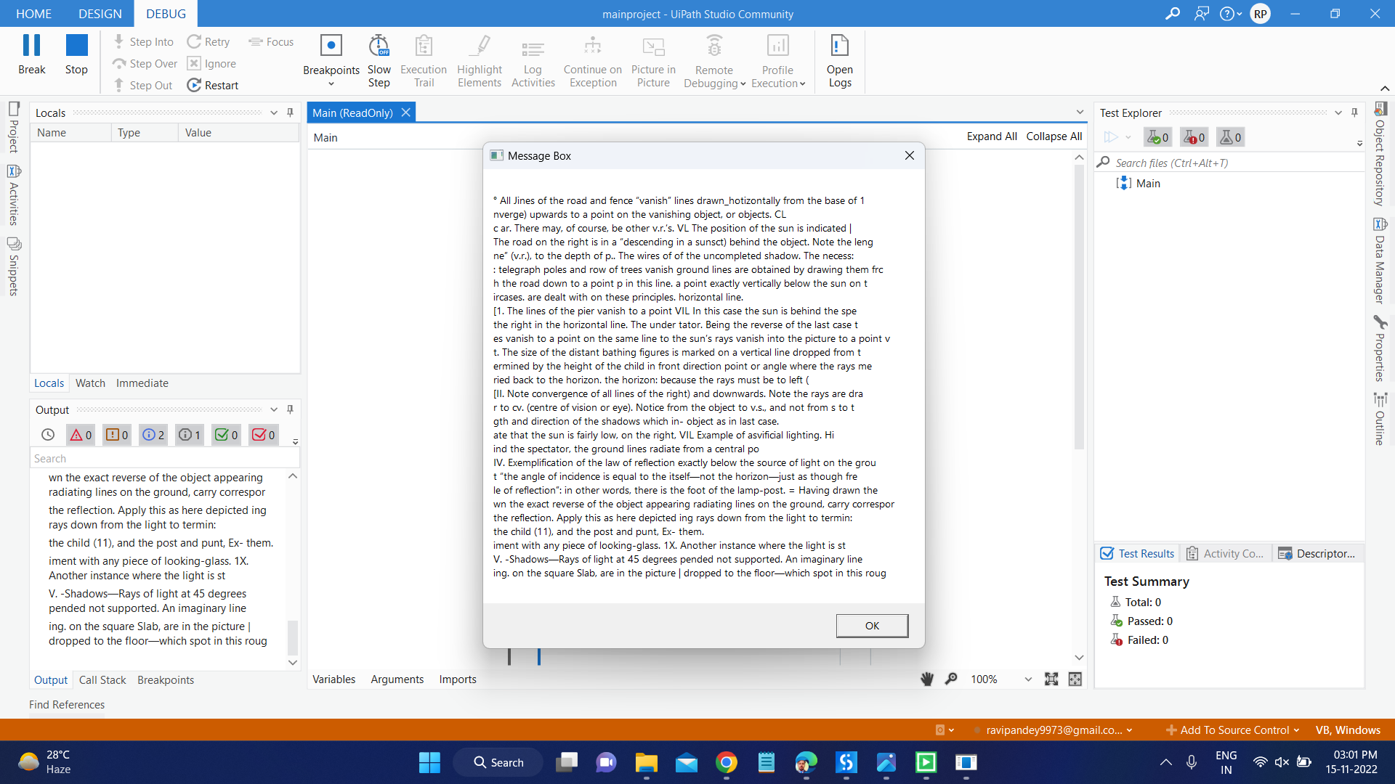

Extracting text from image.

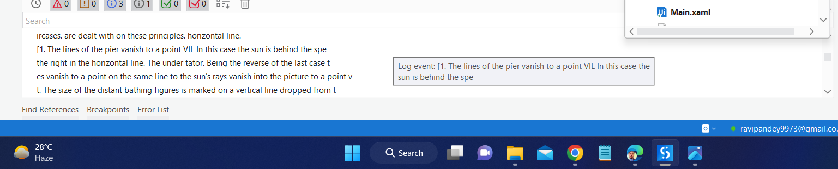

Text save in document file after extracting from image

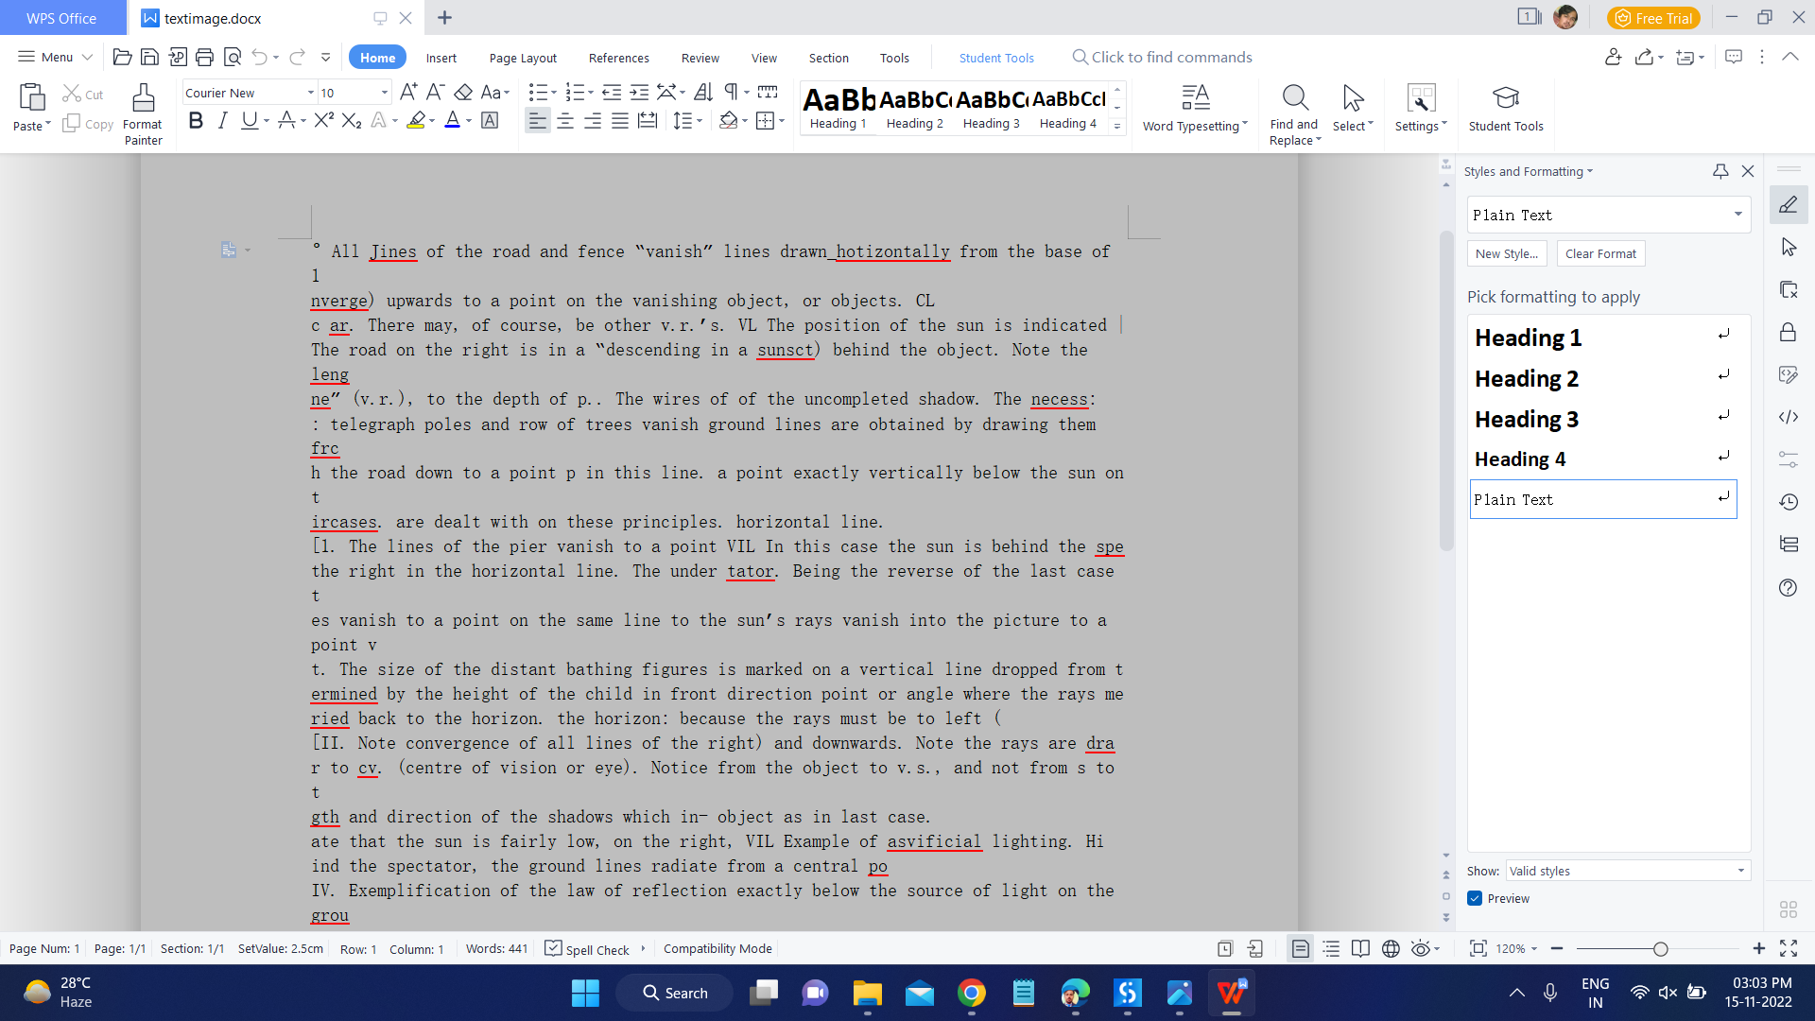

Ravi Pandey

